# Lab: Polymorphism

Problems for exercises and homework for the ["Java OOP" course @ SoftUni](https://softuni.bg/trainings/2245/java-oop-february-2019).

You can check your solutions here: <https://judge.softuni.bg/Contests/1592/Polymorphism-Lab>.

## MathOperation

Create a class **MathOperation**, which should have method add(). Method add() have to be invoked with **two, three** or **four Integers.**

You should be able to use the class like this:

|  |
| --- |
| Main.java |
| **public static void** main(String[] args) **throws** IOException {  MathOperation math = **new** MathOperation();  System.***out***.println(math.add(2, 2));  System.***out***.println(math.add(3, 3, 3));  System.***out***.println(math.add(4, 4, 4, 4));  } |

### Examples

|  |  |
| --- | --- |
| **Input** | **Output** |
|  | 4  9  16 |

### Solution

Class **MathOperation** should look like this:

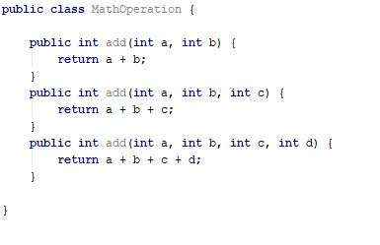

## Shapes

Create class hierarchy, starting with abstract class **Shape**:

* **Fields:**
  + **perimeter : Double**
  + **area : Double**
* **Encapsulation for this fields**
* **Abstract methods:**
  + calculatePerimeter()
  + calculateArea()

Extend Shape class with two children:

* **Rectangle**
* **Circle**

Each of them need to have:

* **Fields:**

**For Rectangle**

* + **height : Double**
  + **width : Double**

**For Circle**

* + **radius : Double**
* **Encapsulation for this fields**
* **Public constructor**
* **Concrete methods for calculations (perimeter and area)**

## Animals

Create a class Animal, which holds two fields:

* name: String
* favoriteFood: String

Animal has one abstract method explainSelf()**: String.**You should add two new classes - **Cat** and **Dog. Override** the explainSelf() method by adding concrete animal sound on a new line. (Look at examples below)

You should be able to use the class like this:

|  |
| --- |
| Main |
| public class Main {  public static void main(String[] args) {  Animal cat = new Cat("Pesho","Whiskas");  Animal dog = new Dog("Gosho","Meat");    System.out.println(cat.explainSelf());  System.out.println(dog.explainSelf());  }  } |

### Examples

|  |  |
| --- | --- |
| **Input** | **Output** |
|  | I am Pesho and my favorite food is Whiskas  MEEOW  I am Gosho and my favorite food is Meat  DJAAF |

### Solution

